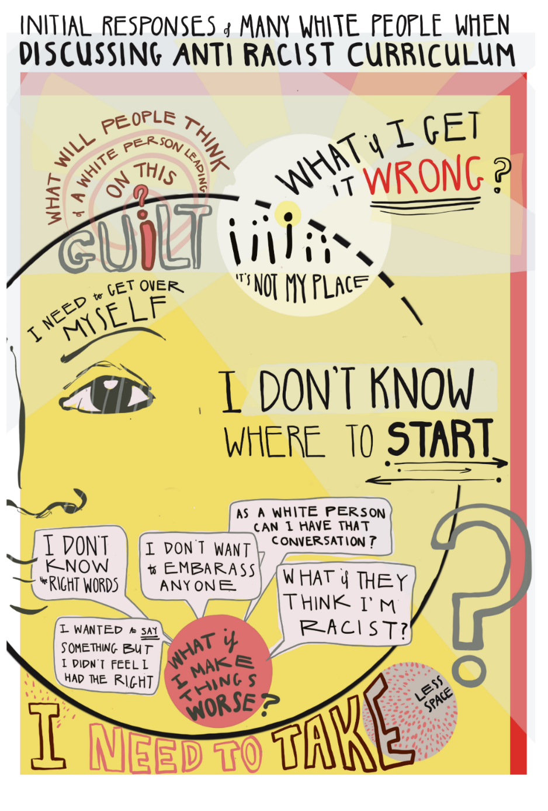
A rectangle poster with words and imagery. The colour scheme is muted with varied shades of yellow as the main background built up with reds, greys, black and pinks to highlight words, move the eye to the next section, and emphasise meaning.
Images are sketched and words are written in a free handwritten style with a large circle outlined across the majority of the poster to draw the eye and link up disparate sections and phrases into a whole. The title at the top is ‘Initial Responses of Many White People When Discussing Anti-Racist Curriculum’
Underneath this and to the left is the word ‘Guilt’ in large grey-outlined writing. The ‘i’ is red, it’s dot serving as the bottom dot of the question mark ending ‘what will people think of a white person leading on this? which frames ‘Guilt’. Tying in with this is a row of small ‘i’s (one of the dotted ‘i’s is circled in bright yellow) which look like small human figures above the phrase the ‘It’s not my place’. And finally the phrase ‘I need to get over myself’ which frames the brow of a half sketched human face. The continued sketches of ‘i’s underlines the focus of the questions which are self-directed and often self-critical.
To the right and in very large writing is ‘What if I get it wrong?’. ‘Wrong’ is thrice underlined and in a different colour (red) to convey the fear about making mistakes or making things worse. This phrase sits somewhat apart from the other sections to add weight to the concern it describes.
Underneath and to the right of the centre of the poster, also in a space of its own in even larger black writing is ‘I don’t know where to start’. ‘Start’ is underlined by arrows facing on opposite directions to convey the feeling of being lost and unsure how to begin.
A cluster of speech bubbles springs out of an urgent red circle with the text ‘What if I make things worse?’ (emphasised as a common worry) and they clamour for space (emphasising the increasing / overlapping concerns) saying ‘I wanted to say something but I didn’t fell I had the right’, ‘I don’t know the right words’, ‘I don’t want to embarrass anyone’, ‘As a white person can I have that conversation?’, ‘What if they think I’m racist?’.
Next to this is a very large question mark outlined in grey – it’s scale and position are there to illustrate the depth of feelings of doubt and uncertainty when discussing ARC.
The bottom phrase is in large chunky sloping letters saying ‘I need to take less space’ with ‘less space’ in smaller text squeezed at the edge of a circle to capture the concerns about taking up too much space.

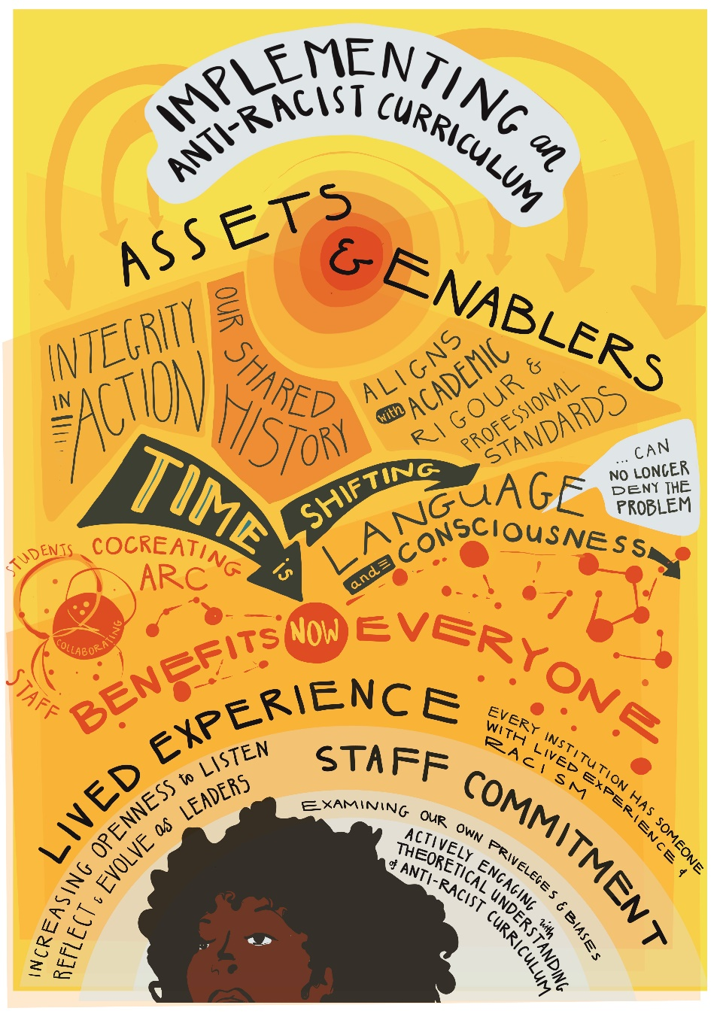
A rectangle poster with words and imagery. The colour scheme is warm and positive with different shades of yellow as the main background, with background shapes in reds and oranges, and dark browns and light grey to highlight sections.
Images are sketched and words are written in a free handwritten style to draw the eye and capture the urgency of the discussion. The phrases which include one words or short phrases and longer sentences are displayed all over the page, sometimes interacting with each other to denote their interconnectedness and sometimes underlined to draw the eye and reinforce their importance. The text reads:
The title ‘Implementing an Anti-Racist Curriculum’ has a light grey background to make it stand out with yellow arrows showering down from it and leading to the subtitle words ‘Assets & Enablers’ and pointing to the bottom two thirds of poster and body of the text which details those assets and enablers.
The second third of the poster has at its centre a red central sun-like shape with radiating circles of oranges and yellows. Underneath these are various phrases in blocked out coloured sections including ‘Integrity in Action’, ‘Our Shared History’, ‘Aligns with academic rigour and professional standards’. ‘Time is’ in yellow lettering within a large grey arrow pointing to a red circle with ‘NOW’ in the middle of it. Next to it is another large arrow with ‘Shifting’ (both arrows stand out in the overall piece) and pointing to the phrase ‘Language and Consciousness’. The word ‘Language’ has a speech bubble with the words ‘…can no longer deny the problem’ coming out of it. It’s in light grey which makes it highly noticeable sitting off centre of the poster amongst the yellow background.

Four circles are interlinked with ‘students’ and ‘staff’ and ‘collaborating’ to visually capture the symbiotic process involved. Next to these are the words ‘Co-creating ARC’ underlined by red balls connected by red lines (liked atoms) which weave around the words ‘benefits everyone’ which have the red circle with ‘now’ in the middle of them conveying a sense of movement, dynamic connections and progress.

The bottom third of the poster is framing the drawing of the top half of a black woman’s head with afro hair in the foreground framed by radiating semi-circle bands of colour and text behind her. ‘Lived experience’ and ‘Staff Commitment’ are in the largest boldest lettering. Other statements are ‘every institution has someone with lived experience of racism’, ‘increasing openness to listen, reflect and evolve as leaders’, ‘examining our privileges and biases’ and the final phrase at the bottom and nearest the female figure is ‘actively engaging with theoretical understanding of anti-racist curriculum’.

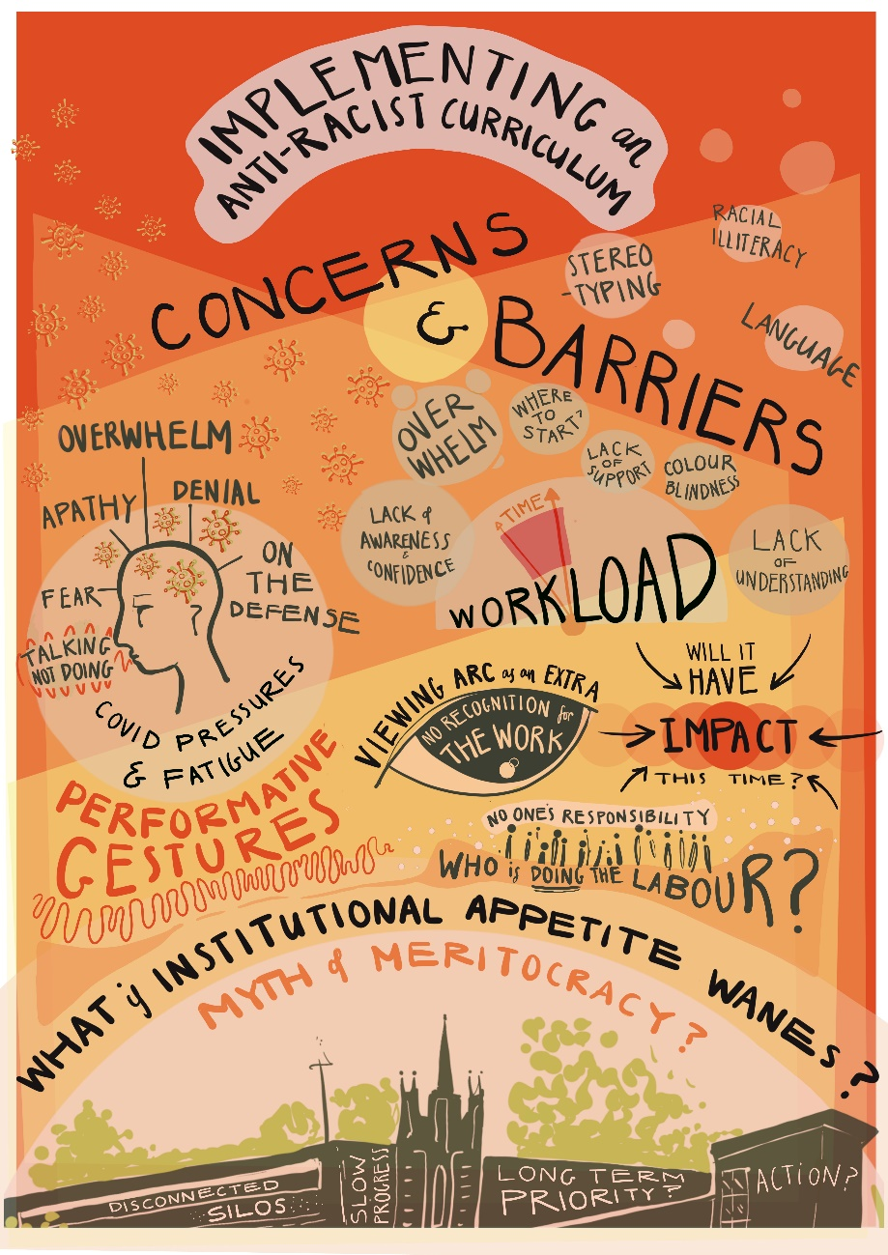
A rectangle poster with words and imagery. The colour scheme is warm and positive. The background has different angular shaded sections beginning with red at the top then grading down to oranges to yellows and finally pale pink. Small sketches of suns pepper the left top side of the poster with bubbles on the right hand side.

Images are sketched and words are written in a free handwritten style to draw the eye and capture the urgency of the discussion. The phrases which include one words or short phrases and longer sentences are displayed all over the page, sometimes interacting with each other to convey their interconnectedness and sometimes underlined to highlight them, catch reader’s attention, and reinforce their importance.
The title at the top is ‘Implementing an Anti-Racist Curriculum’ with a subtitle of ‘Concerns & Barriers’. This is surrounded by pale pink bubbles with phrases ‘stereotyping’, ‘racial literacy’ and ‘language’ inside them. Underneath ‘Barriers’ are various bubbles of text framing a semi-circle sketch of a clock with hands pointing to ‘time’ (denoted by a red wedge squeezed between two clock hands) intersecting the word ‘workload’ to capture the time and work pressure staff face. The surrounding bubbles say ‘lack of awareness and confidence’, ‘overwhelm’, ‘where to start?’, ‘lack of support’, ‘colour blindness, ‘lack of understanding’.

To the left is an outlined profile of a human head within a pale pink circle. It’s drawn outline has lines coming out of it leading to various words ‘fear, ‘apathy’, ‘overwhelm’, ‘denial’, ‘on the defence’, ‘talking not doing’ which has red arrows surrounding it for extra emphasis. Underneath the drawn head is ‘covid pressure and fatigue’. The busy sketch conveys the feelings of confusion amid multiple pressures, stress and negativity. Underneath this circle is the largely written words ‘performative gestures’ in a strong red underlined for extra boldness.
To the right of this is a black and pale pink sketch of an eye with the words ‘no recognition of the work’ enclosed in the pupil and the top arc of the eye framed by ‘viewing ARC as an extra’.
Next to this is the word ‘IMPACT’ written in bold across red and orange interconnecting circles with arrows pointing into the word with the question ’will it have IMPACT this time?’ surrounding it. The arrows provide an interrogative critical feel to the question.
A small sketch of people (basic heads and bodies) in a row also looks like ‘i’s. The phrase above them is ‘no one’s responsibility’ and the phrase below them ‘who is doing the labour?’ The ‘i’s dually serve as reminders that it is people behind this work but also that every individual has a part top [play and responsibility.
The final bottom image is a drawing of an old building – like a university– with trees and a semi-circle sky above. The building has phrases written on it including ‘disconnected silos’, ‘long term priority?’, and ‘action?’. The sky asks ‘myth of meritocracy?’ and is framed by a wider border asking ‘what if institutional appetite wanes?’. The sketch and words combine to capture concerns and barriers felt (and its suggest caused) by the education institution itself.

