Associate Opportunities: SurveyMonkey Apply account registration and application

Enter the below SurveyMonkeyApply URL into your browser:
https://advancehe.smapply.org/prog/associate_opportunities_australia/
If you have previously created a SurveyMonkey Apply account, and are logged in, you can start your application immediately. If not, you must first register on the site (takes two minutes).
Click the green Register button.
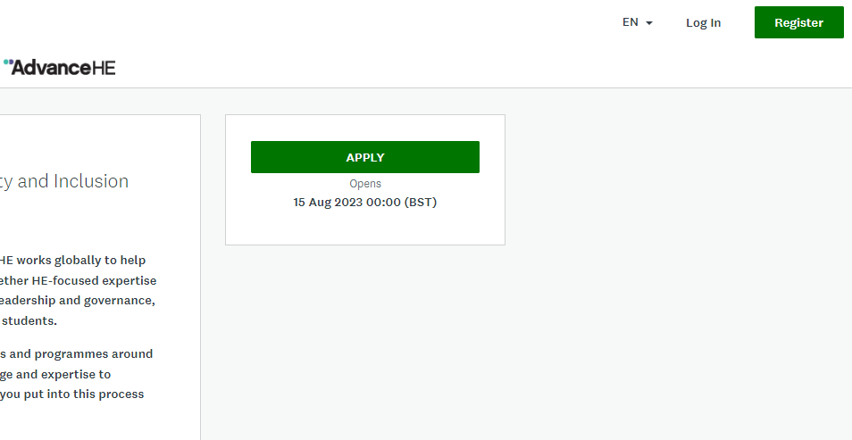

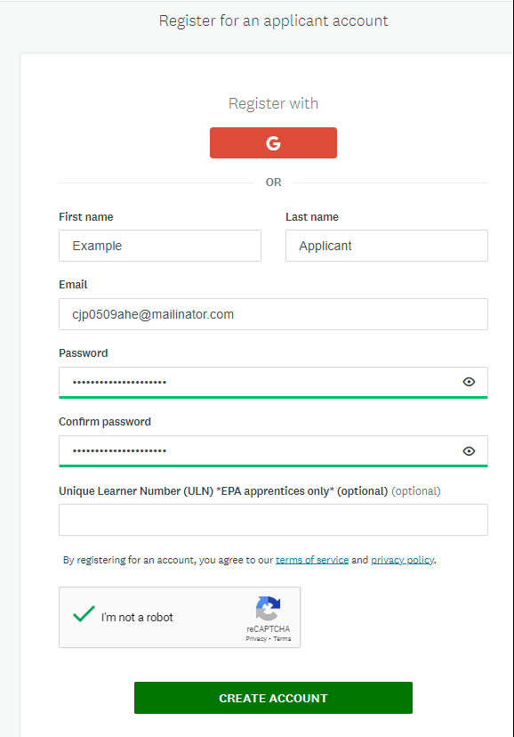
Follow the registration process and click on Create Account when permitted.
A verification email will be sent to the email account entered. This should be sent within seconds- check your junk/spam box if you don’t see it immediately.
Click on “Confirm email address”. This will verify and activate your account. You will not need to do this again.
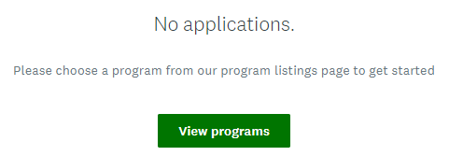
Once your account is verified you will be automatically logged into the site. Click on “View programs”.

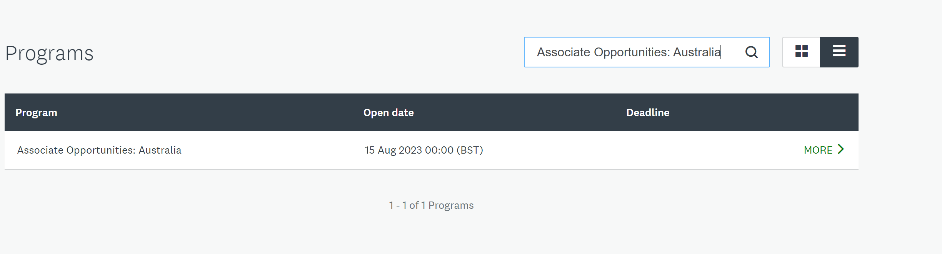
Locate the Associate Opportunities application “program”. You can search by name or sort the active programmes alphabetically by clicking on the column header.
You can toggle between Tiles or List format using the icons to the right of the search bar.
Click on the green “more” button to enter the programme.

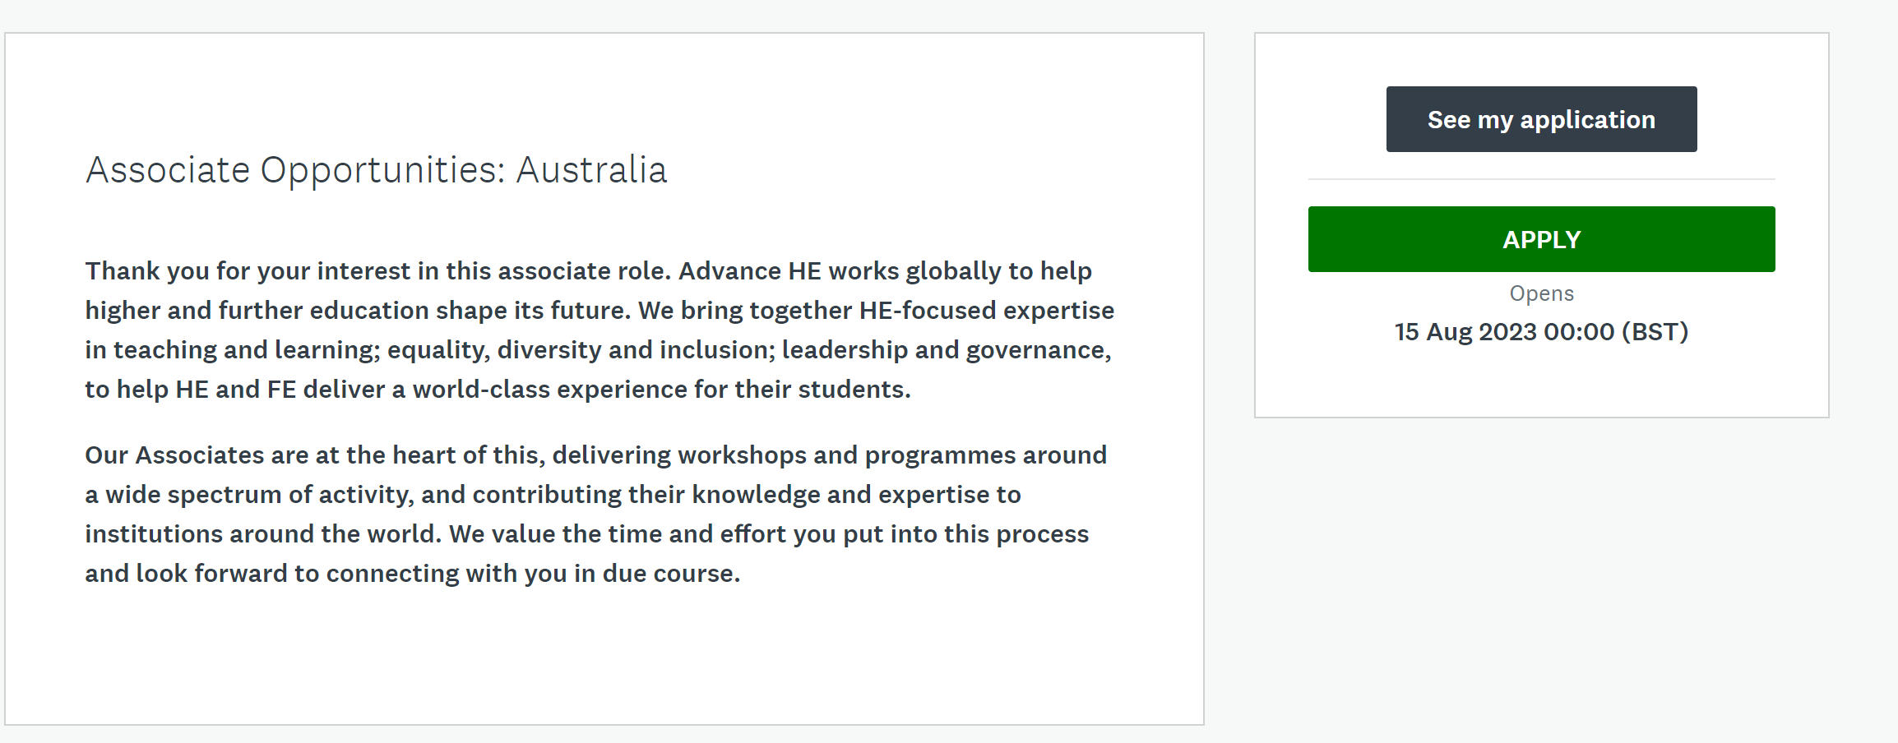
Click on “Apply” to start your application.

